Installation.

Install and enable the following list of modules:
- print (enable PDF version) - http://drupal.org/project/print (7.x-1.2)
- protected downloads – custom module (attached)
- token - http://drupal.org/project/token (7.x-1.4)
- webform - http://drupal.org/project/webform (7.x-3.18)
- webform_protected_downloads – patched module (attached)

“Print” module requires a library to generate PDF files from HTML. Therefore upload “dompdf” library in “sites/all/libraries” directory of your site.
Link to dompdf: http://code.google.com/p/dompdf/downloads/list (DOMPDF 0.6.0 beta 3)
Please read “install.txt” file of the “print” module to configure the “dompdf” library properly.

Configure chosen content type to add a field. This example documentation uses content type “Article” but it can be substituted be any other content type.
Go to “Administration/Structure/Content types/Article” and click “manage fields” link. While adding a new field select the “Downloads button” option from the dropdown list under the “Field Type” label. Save the changes. Go to the “manage display” link of the chosen content type, locate the added field and select the value “<Hidden>” from the “Label” dropdown list. Save the changes.

Generation of PDF files from the content of a node.

Go to “Configuration/User Interface/Printer, email and PDF versions/PDF” and check if the “PDF generation tool” option refers to “sites/all/libraries/dompdf/dompdf_config.inc.php”. Scroll down the page and save it in any case (this will enable the generation of PDF files).

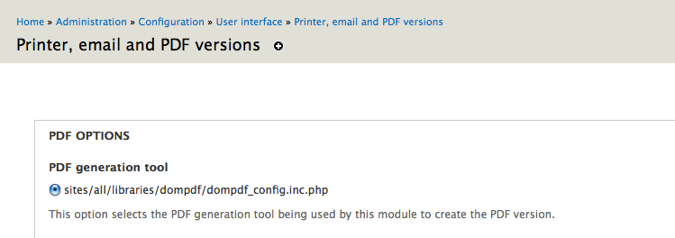

Now if you create a node of type “Article” you will see the “Download PDF” button which generates the PDF file of your node content by clicking on it.

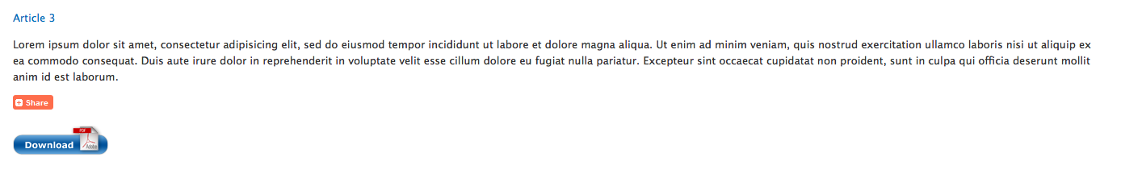

You will also see “Printer-frindly version” and “PDF version” links on the page added by the “Print” module. To remove those links go to the “Structure/Content types/Article/Printer, email and PDF versions” tab and uncheck the “Show link” and “Show Printer-friendly URLs list” checkboxes. Save the changes.
Note: this step can also be done per node instead of content type.

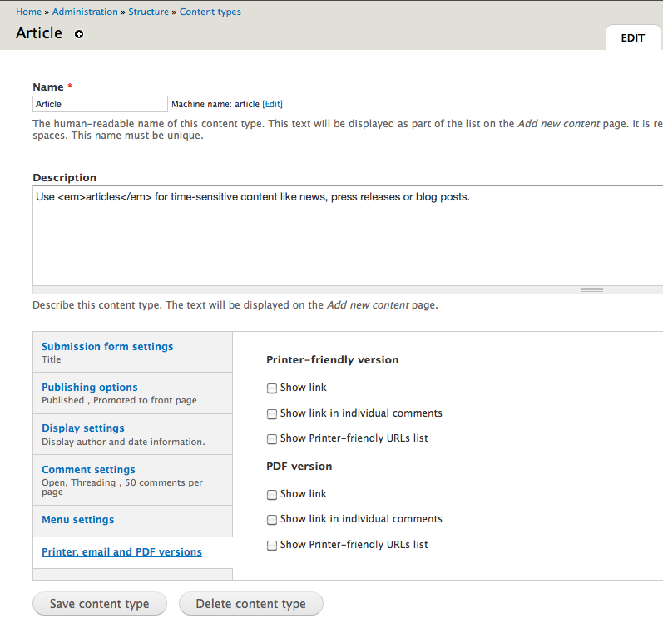

To configure the display settings of the PDF (in other words which fields will be displayed in generated PDF) proceed the following steps. Go to the “Structure/Content types/Article/manage display” tab and open the “Custom display settings” area. Check the “Print” checkbox and save the changes. You will see the “Print” tab appearing next to “Default” and “Teaser” tabs. Click the “Print” tab and drag the undesired fields under the “Hidden” label (see screenshot).

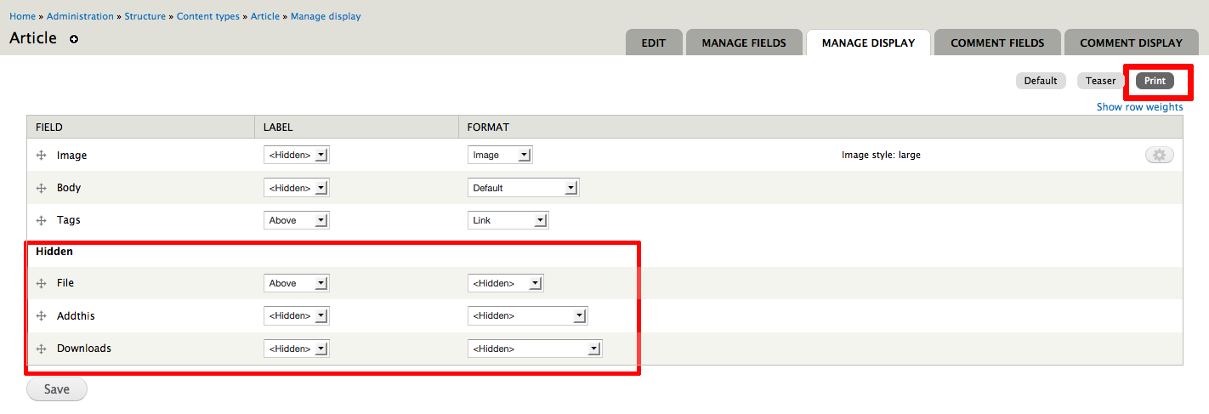
On the screenshots below you can see the differences in PDF file.
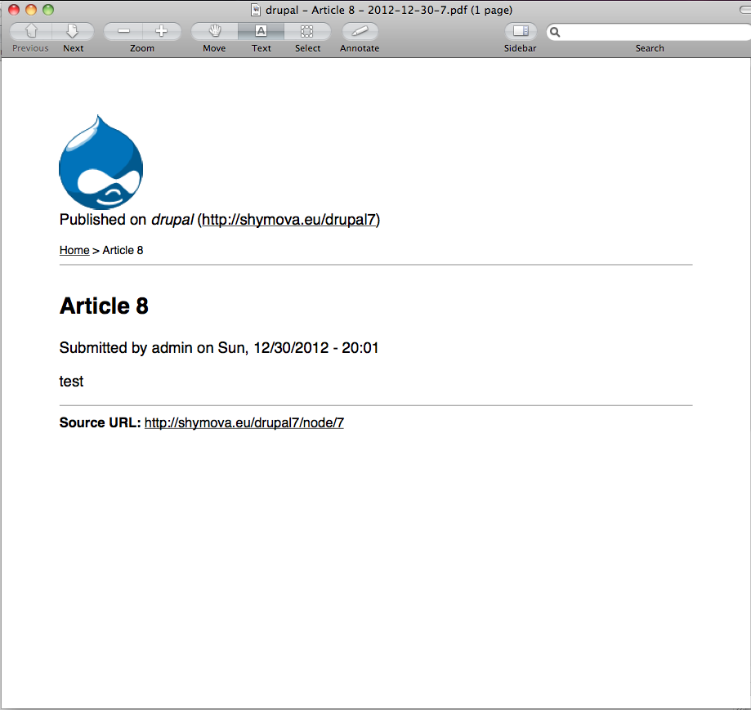
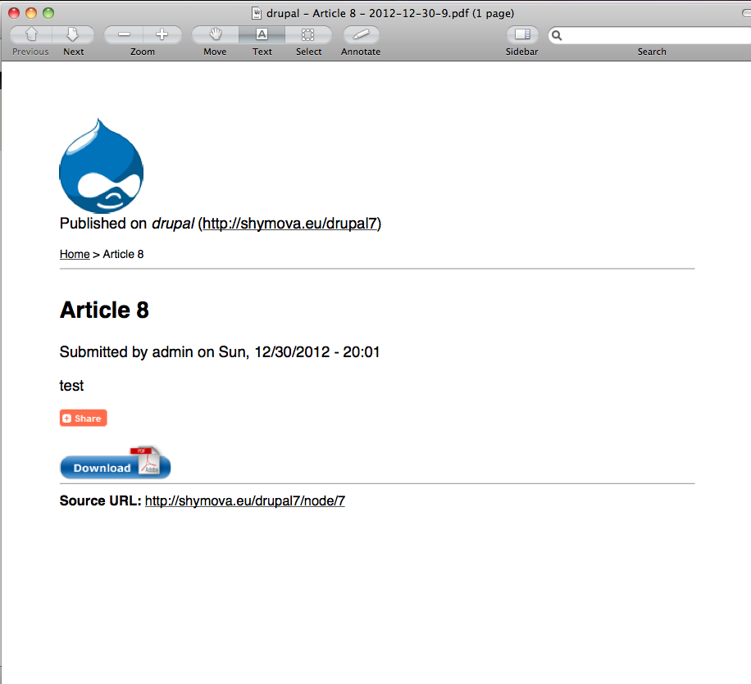
Before “Print” display was configured After

Configure access to restricted content

Set the possibility to add private files in Drupal. Create a directory, for example “sites/default/private_files”. Go to “Administer/Configuration/Media/File system”, set path to private files in the “Private file system path” setting and set “Default download method” to “Private local files served by Drupal”.

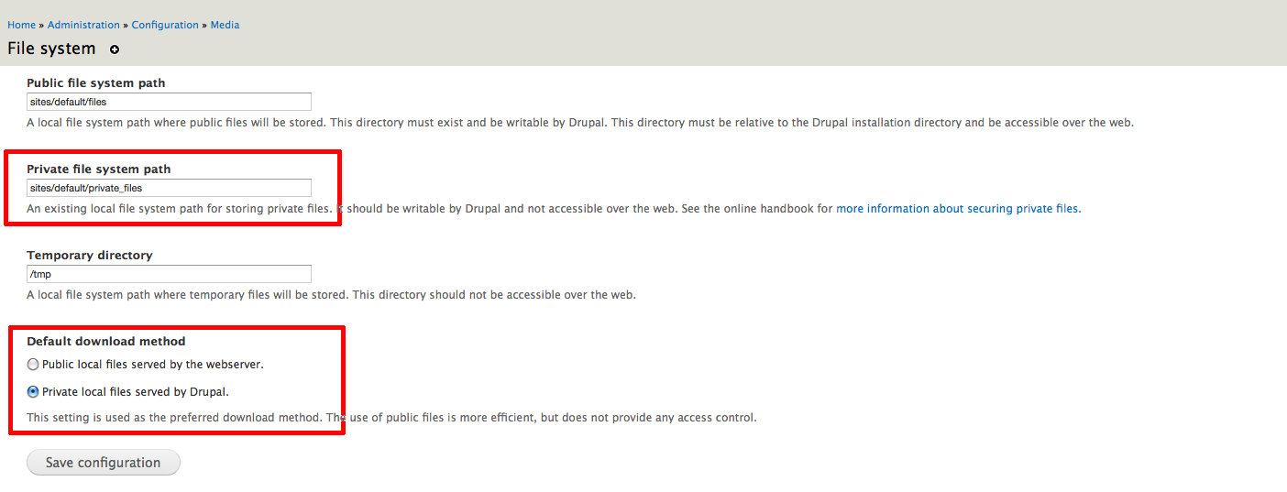

Go to “admin/people/permissions” and edit the new “Approve webform protected downloads” permission for a role you are logged in on the site.

Go to “Administration/Structure/Content types/Article” and click “manage fields” link. While adding a new field select the “File” option from the dropdown list under the “Field Type” label. On the settings page of the new field add “pdf” in the “Allowed file extensions” setting.

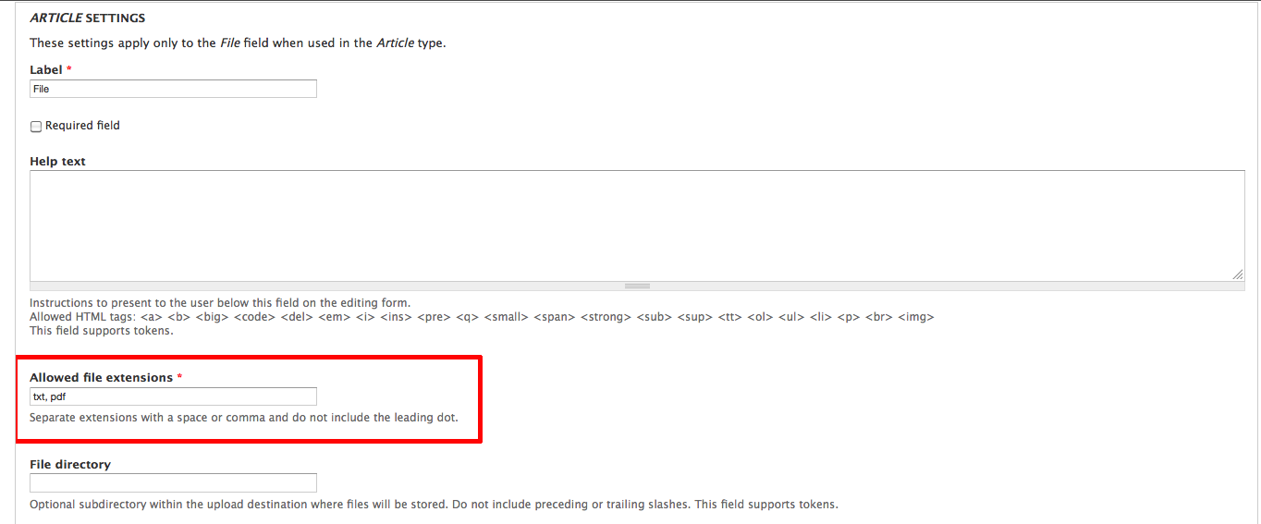
Set “Upload destination” setting to “Private files”. Save the changes.

Go to the “manage display” link of the chosen content type, locate the added field and select the value “<Hidden>” from the “Label” dropdown list. Save the changes.

Now let's enable webform for our content type. Go to “Configuration/Content authoring/Webform settings” and check the checkbox next to content type “Article” in “Webform-enabled content types” setting. Save configuration.

Let's hide webform from view until the user clicks the “Get restricted content” link. Go to the “manage display” tab of your selected content type (“Article” in our case) and set the “Format” option of a “Webform” field to “Hidden”.

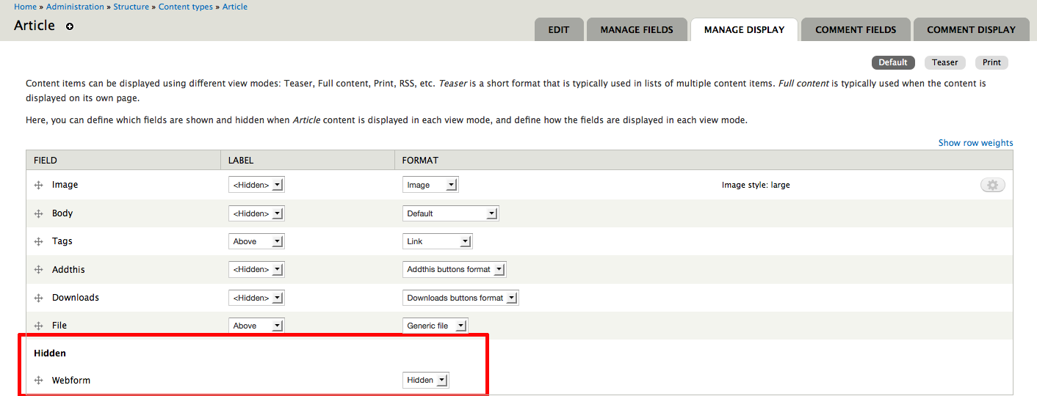

Create a node of type “Article” and attach a PDF file to it using the previously added “File” field. After saving the node “Webform” and “Protected downloads” tabs should appear.

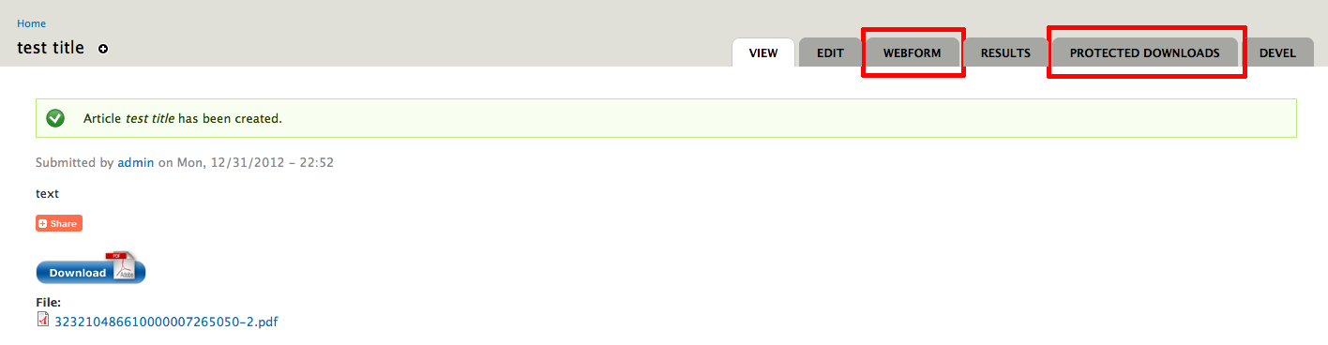

Go to the “Webform” tab and add the required fields which user needs to fill in before access to restricted content is granted (for example: email, first name, last name and company). Check “Mandatory” checkbox for each of those fields.

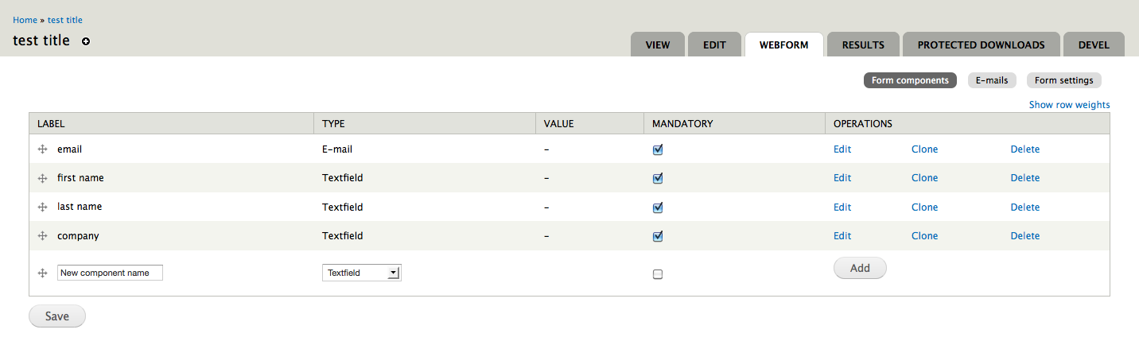
Go to the “Protected downloads” tab, check “Protected” checkbox next to the added PDF file and set “Mail confirmation to” setting to “email”.
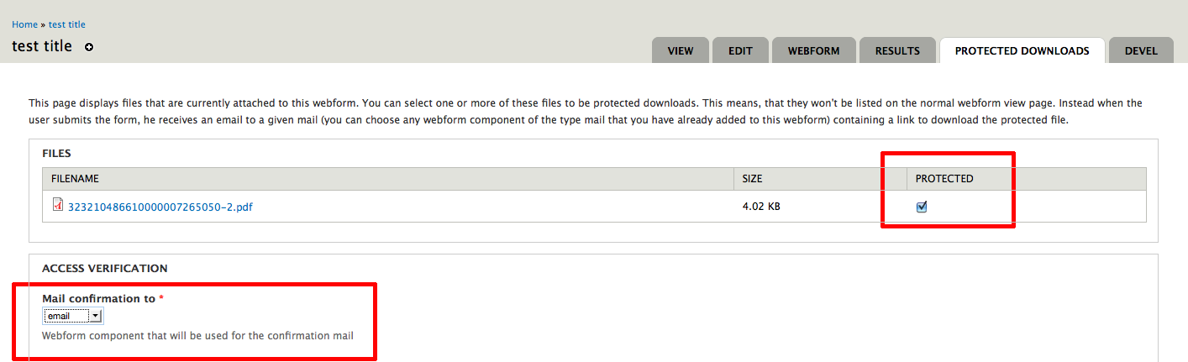
In the following fields on the same page you can adjust the text showing to the user and choose the option which determines how the user gets access to restricted content. Note: “Requires approval” and “Redirect to downloads page after form submission” options can not be selected together. If you select “Requires approval” option you will first need to allow or deny access to restricted content for each particular user submission.
Let's check the “Requires approval” checkbox. When the user loads the node page (or page which shows all nodes of specific content type along with a “Protected downloads” field) and clicks the “Get restricted content” link a form with 4 fields should appear. After the user submits the form an approval request is created.

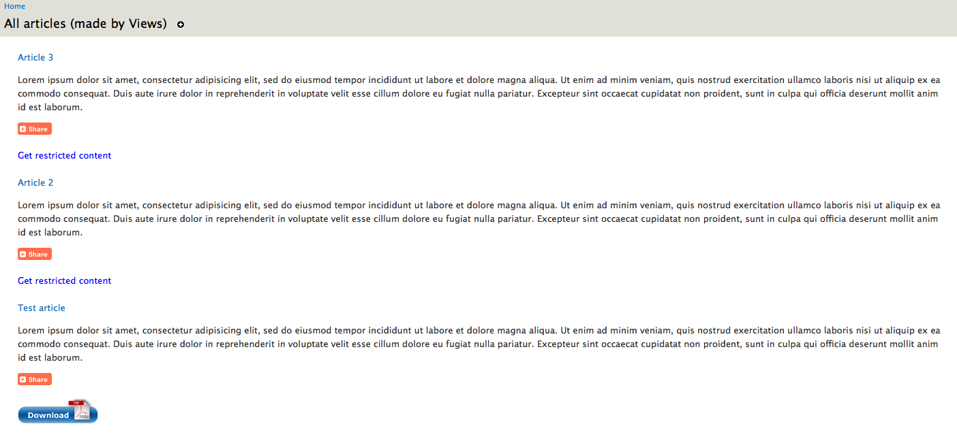
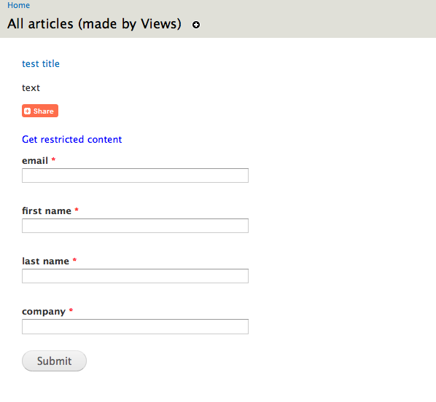

All approval requests are accessible on “http://link-to-your-site/wpd-submissions”.

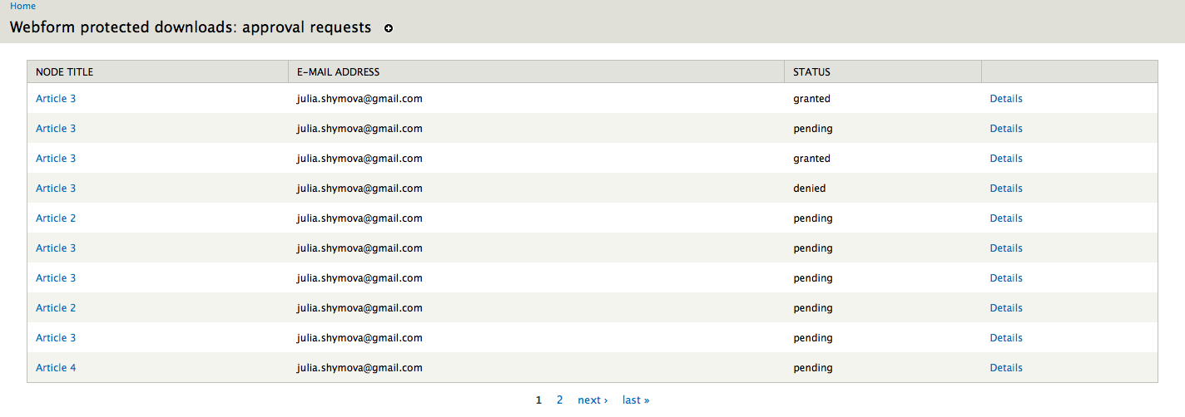
By clicking on the “Details” link a page of a corresponding submission will load where you can grant or deny access to a PDF file. After access is granted the user will get an email with a link to required PDF file.
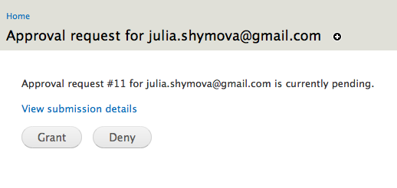

To change HTML and CSS of “PDF downloads and restricted contents” field edit the following files accordingly:
- downloadsbuttonfield.tpl.php
- downloadsbuttonfield.css
- restrictedcontentfield.tpl.php
- restrictedcontentfield.css

Those files are located inside the “protected_downloads” module directory.

If you want to get emails every time the webform of a specific node is submitted go to the “Webform” tab in edit interface of selected node and select the “E-mails” tab there.

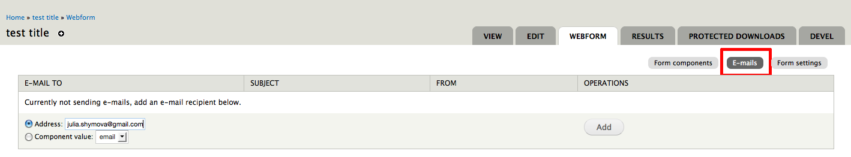
Set the right address in the “Address” field and click the “Add” button. On the next page “Edit e-mail settings” select “Custom” option in “E-mail to address” setting. You can also edit the body of an email under the “E-mail template” label and add there a link to the list of all approval requests (http://link-to-your-site/wpd-submissions).

